- What is the total amount of petrol in volume sold by every distributor?

//DATA LOAD

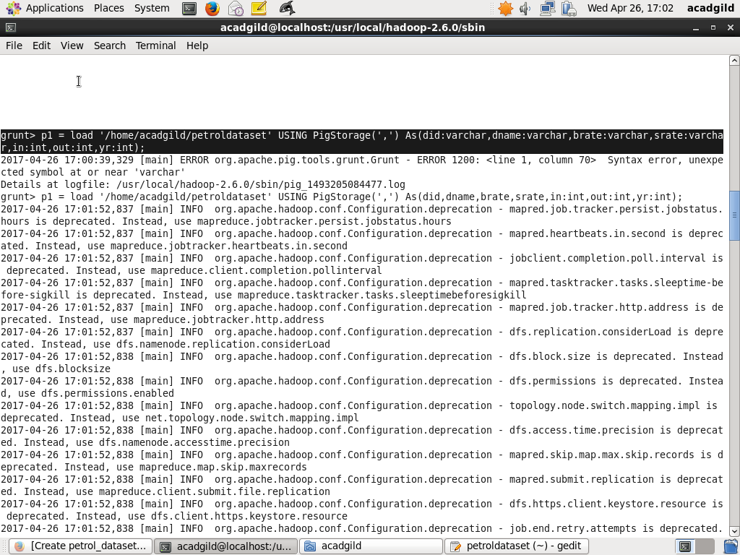

//QUERY EXECUTION

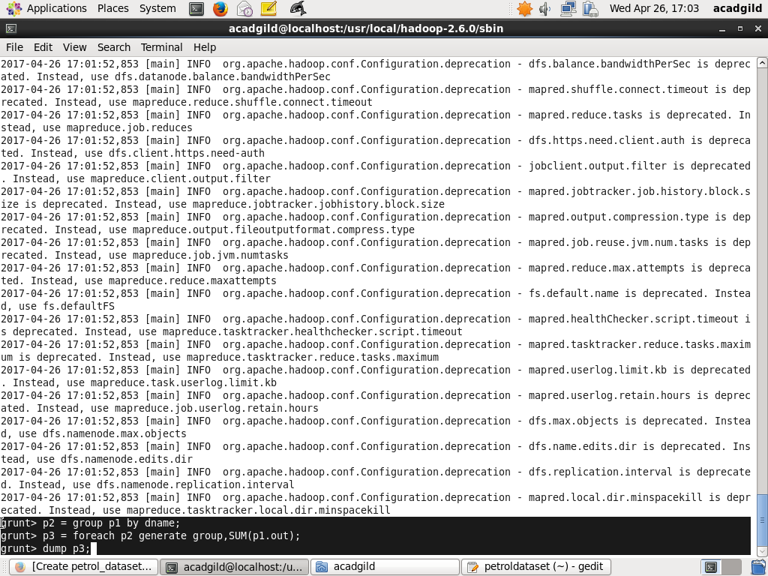

//RESULT

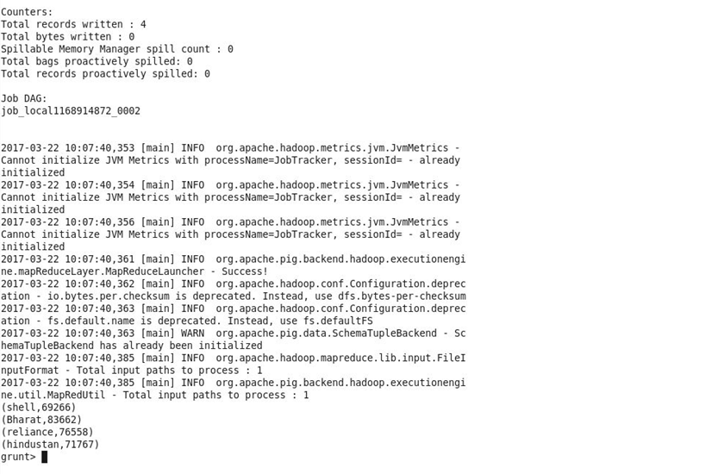

- Which are the top 10 distributors ID's for selling petrol? Also display the amount of petrol sold in volume.

//DATA LOAD

//QUERY EXECUTION

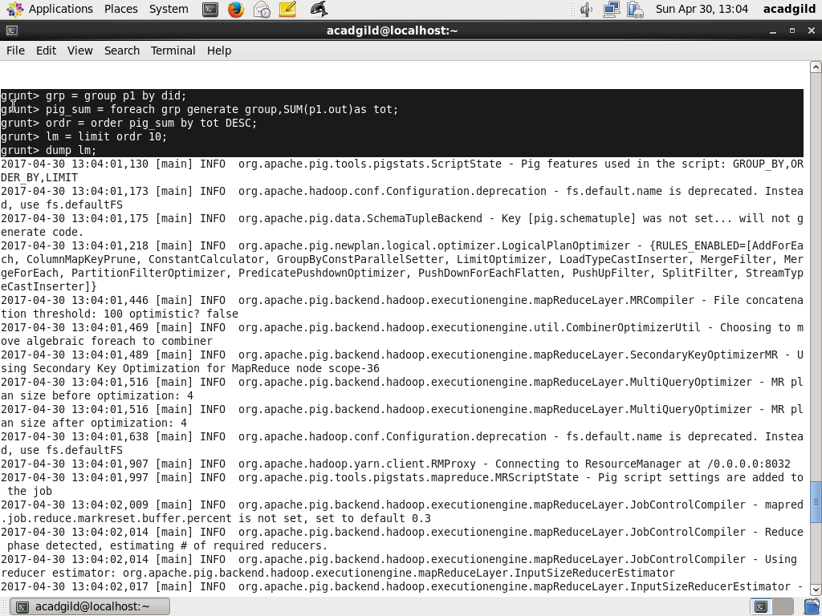
//RESULT

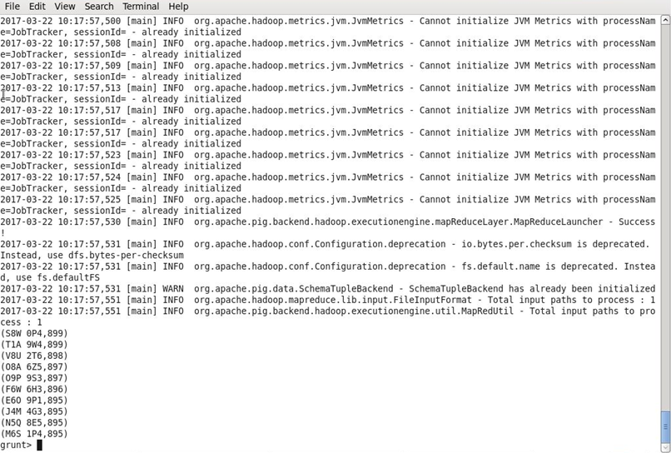

- List 10 years where consumption of petrol is more with the distributer id who sold it.

//DATA LOAD

//QUERY EXECUTION

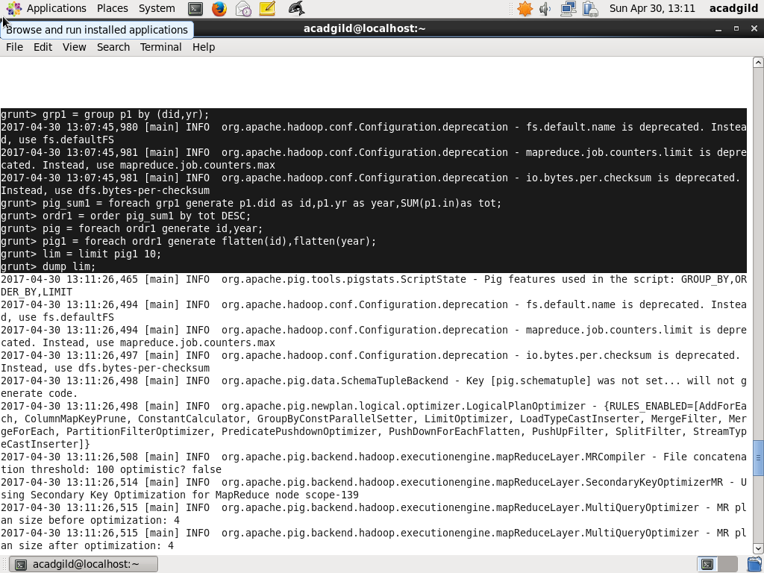

//RESULT

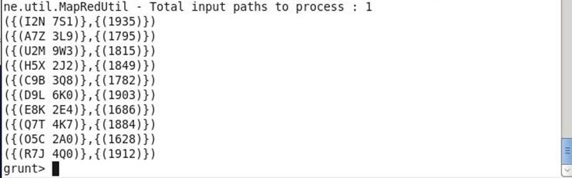

4.Find the distributer name who sold petrol in least amount.

//DATA LOAD

//QUERY EXECUTION

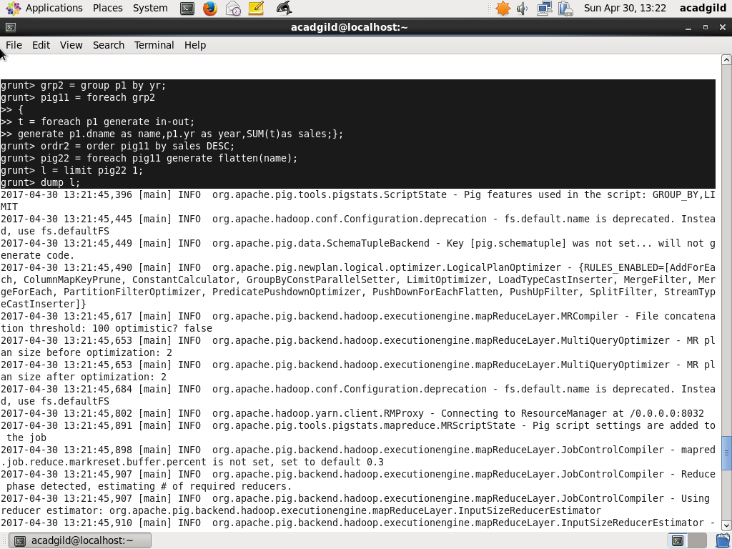
//RESULT

